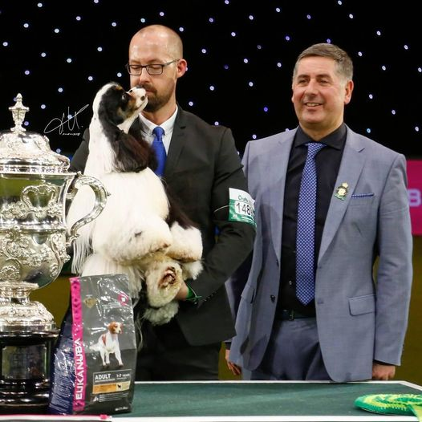 |  |  |  | REQUIREMENTS OF A DOG SHOW JUDGE SEMINAR
Monday 21st November 7-9pm
Online via TEAMS platform
£15 payable on booking

The RDSJ Seminar is a KC JEP Level 1 Requirement for ALL judges who have not yet given CCs.

Once you have undertaken the seminar ONLINE, then you are eligible to undertake the EXAM (level 2 requirement) ALSO ONLINE via the KC JEP platform.

About our KC accredited trainer – Mr Jeff Horswell
Jeff first judged in 1982, and first awarded CCs in 1989, at the Scottish KC, to Wire & Min Wire Dachshunds. He judged Min Wires at Crufts in 2000, his first Hound Group in 2000 and BIS in 2003. Jeff is approved to award CCs in over 150 breeds across all 7 UK groups, along with BIS and the 7 UK groups. He has judged the Hound & Pastoral Groups at Crufts, and judged Best in Show at Crufts in 2017. Jeff has judged many parts of the world including Sweden, Finland, Denmark, Norway, Iceland, Russia, Australia, Estonia, Latvia, Spain, Portugal, Italy, Holland, Hungary, Croatia, Slovenia, Poland, Ireland, USA, Canada, Japan, Argentina, South Africa, Trinidad & Barbados. He is a former member of the KC Board and its Judges’ Committee, and has been very involved in the KCs judges training scheme. Jeff was elected President of the Dachshund Club in 2021.
 |  | Requirements of a Dog Show Judge Seminar
 |  | Level 1 JEP Requirement
 |  | secretary@midlandcollieclub.co.uk
 |  | www.midlandcollieclub.co.uk

